We use Present Continuous Tense to talk about actions HAPPENING NOW.
Look at the following examples and identify the rule ☺

I am listening to music now.
She is playing tennis with her friend.
Stuart is having his lunch.
It is raining outside.
We are learning a new tense.
You are swimming in the pool.
They are singing.
Look at the example and try to understand the rules.
Work __ working
Do __ doing
Go __ going
Write __ writing
Come __ coming
Ride __ riding
Swim __ swimming
Run __ running
Chat __ chatting
Add –ing the the following verbs:
Eat _________
Have _________
Play _________
Read _________
Sit _________
Cry __________
Walk _________
Hold _________
Sleep _________
Listen _________

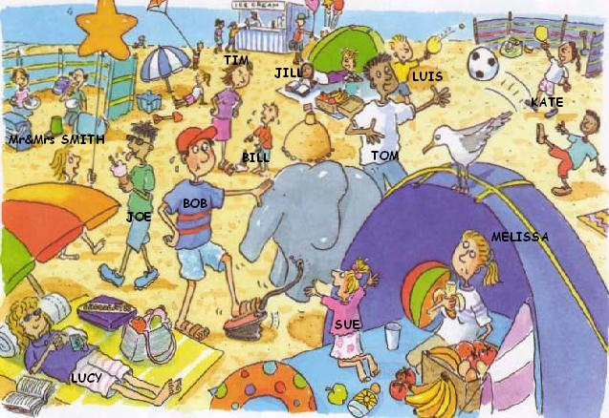
LISTEN
EAT
FEEL HAPPY
HAVE A PICNIC
PLAY
FILL WITH AIR
WALK
CRY
LOOK
CATCH
BUY
READ
Write sentences about the people in the picture. Use the verbs in the word bank.
Tim ____________________________________
Melissa _________________________________
Joe ____________________________________
Tom ____________________________________
Kate and Luis _____________________________
Lucy ____________________________________
Bill _____________________________________
Jill _____________________________________
Bob ____________________________________
Mr & Mrs Smith __________________________
Sue____________________________________
Answer the questions but give long answers:
Is Sue listening to music?
____________________________
Is Jill reading a book?
____________________________
Are Mr & Mrs Smith chatting?
____________________________
Are Luis and Kate playing golf?
____________________________
Is Tom sitting?
____________________________
Is the bird standing on the tent?
____________________________

